A fundraiser for the

GLOBAL DOWN SYNDROME FOUNDATION
funding life-changing research and life-saving medical care for children and adults with Down syndrome

Wednesday, June 7, 2023  Hyatt Regency Washington on Capitol Hill

6:00PM Cocktail Reception | 7:00PM Performance & Program | 9:00PM Concludes
The Global Down Syndrome Foundation (GLOBAL) is the largest non-profit in the U.S. working to save lives and dramatically improve health outcomes for people with Down syndrome.
GLOBAL’s annual AcceptAbility Gala brings together policymakers from both sides of the aisle, key scientists from NIH, and our Down syndrome community. Together, our advocacy efforts have increased the NIH Down syndrome research and medical care budget by nearly $200 million over the last five years! The AcceptAbility Gala is an opportunity to celebrate our success, especially major new federal research funding increases after years of being one of the least funded genetic conditions.

Ambassador: | Quincy Jones Exceptional Advocacy Awardees: |  | Special Guests:
Abby Ashbrook | Congresswoman Katherine Clark (D-MA) Congressman Pete Stauber (R-MN) |  | Congressman Robert Aderholt Congressman Tom Cole Congresswoman Rosa DeLauro  Congresswoman Cathy McMorris Rodgers
Gala Committee:  Jan Adams | David Egan | Matthew Perin | Frank Stephens | Amy Best Weiss
Cory Alexander Kevin Brennan | Natalie Farr  Erin Book Mullen | Cliff Riccio Julie Riccio | Marissa Watkins | Salo Zelermyer

2023 Congressional Hosts (In formation): Congressman Robert Aderholt Congressman Katherine Clark Congressman Tom Cole

Congresswoman Rosa DeLauro Senator John Hickenlooper

Congresswoman Cathy McMorris Rodgers

Congressman Pete Stauber

2023 Honorary Congressional Committee (In formation):
Congressman Gus Bilirakis Congressman Brendan Boyle Congressman Buddy Carter Congressman David Cicilline Congresswoman Yvette Clarke Congressman Emanuel Cleaver Congressman Lou Correa Congressman Jason Crow Senator Ted Cruz Congresswoman Suzan DelBene Congresswoman Virginia Foxx  Congresswoman Lois Frankel Congressman Robert Garcia | Congressman Andrew Garbarino Congressman Wesley Hunt Congresswoman Sheila Jackson Lee Congresswoman Jen Kiggans Congressman Derek Kilmer  Senator Amy Klobuchar Congressman Darin LaHood Congressman Bob Latta Senator Cynthia Lummis Senator Ed Markey Congressman Brian Mast  Congresswoman Lucy McBath Congressman Michael McCaul | Congressman Pat McHenry Congressman Rob Menendez Congresswoman Carol Miller Senator Chris Murphy Congressman Greg Murphy Congressman Chris Pappas Senator Marco Rubio Congressman Steve Scalise  Congresswoman Abigail Spanberger Congresswoman Haley Stevens Congresswoman Jill Tokuda Senator Roger Wicker

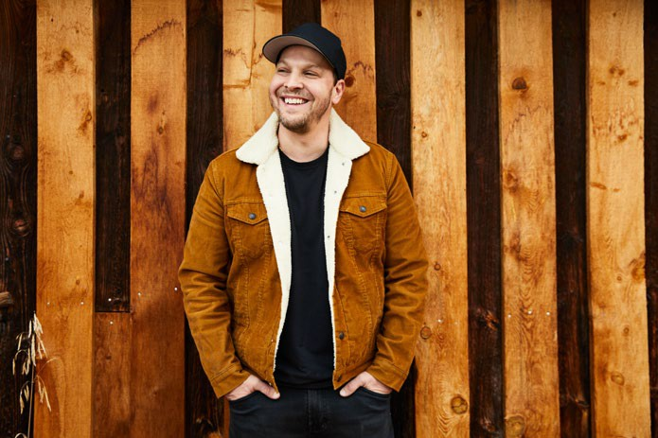
Musical Entertainment & Special Guests:

GRAMMY® Award-nominated multiplatinum singer & songwriter Gavin DeGraw Dance Performances by RhythmXpress & Robert Wallop

Emcees:

Kyra Phillips, ABC News Correspondent John Roberts, Fox News Channel Anchor

PAST QUINCY JONES EXCEPTIONAL ADVOCACY AWARD HONOREES

Quincy Jones, Music Icon Eva Longoria, Award-Winning Actress
DeOndra Dixon, Dancer, Self-Advocate Madeline Stuart, Model, Self-Advocate
Timothy P. Shriver, Chairman of Special Olympics Congressman Tom Cole Former Congressman Patrick J. Kennedy Congresswoman Rosa DeLauro
Karen Gaffney, Champion Swimmer, Self-Advocate Colin Farrell, Award-Winning Actor
John C. McGinley, Award-Winning Actor Zack Gottsagen, Award-Winning Actor, Self-Advocate
Congresswoman Cathy McMorris Rodgers Former Congresswoman Cheri Bustos
Congresswoman Eleanor Holmes Norton Former Senator Roy Blunt
Congressman Pete Sessions Amanda Booth, Supermodel, Actress Sujeet Desai, International Musician, Self-Advocate Megan Bomgaars, Actress, Self-Advocate Jamie Foxx, Academy Award & Grammy Award Winner Caterina Scorsone, Award-Winning Actress Tim Harris, Business Owner, Self-Advocate Marián Ávila, Model, Self-Advocate
Luke Zimmerman, Actor, Self-Advocate Former Congresswoman Lucille Roybal-Allard
Kyra Phillips, Award-Winning Journalist Former Congresswoman Jaime Herrera Beutler
Former Senator Tom Harkin John Lynch, 49ers GM & NFL Hall-of-Famer
Congressman Chris Van Hollen Bryan Russell Mujica, Politician, Self-Advocate
Senator Jerry Moran Senator Steve Daines
Beverly Johnson, Supermodel Senator John Hickenlooper
Brad Hennefer, Golfer, Self-Advocate Eric Dane, Award-Winning Actor
Anna and John J. Sie, Cable TV Pioneers David Egan, Author, Self-Advocate
Jamie Brewer, Actress, Self-Advocate
Frank Stephens, Author, Actor, Self-Advocate

PAST GLOBAL AMBASSADOR HONOREES

Sophia Kay Whitten Chase Turner Perry Katherine Winfield DeOndra Dixon Samantha Stevens Alex Sessions
Cole Rodgers
Steven Dulcie
Katherine Felicia Norton Clarissa Capuano
Louis Rotella IV Marcus Sikora Frank Stephens Sam Levin
CC Mullen
Charlotte Fonfara-LaRose Walt Snodgrass
Caroline Cardenas Archie & Sevy Eicher Jonah Berger
Micah Quinones

